# PROPS

# Single props

List-component

import React from 'react'

**const** List = (props) **=>** {

  return (

    <div>

    <h1 className='bg-red-200 p-1 w-[10em]'>{props.text}</h1>

  </div>

  )

}

export default List

now send any kind of data through jsx of this component,the props will auto matically catch it

normal single text

import React from 'react'

import './App.css'

import List from './components/List'

import List2withDataObject from './components/List2withDataObject'

**function** App() {

**const** data=[

    {

       name:"cat",

       category:"tiger"

    },

    {

       name:"dog",

       category:"wolf"

    }

  ]

  return (

    <>

   <List text="hello"/>

   <List text="hii"/>

   {data?.map((animal,index)**=>**{

   return  <List2withDataObject key={index} index={index} {...animal}/>

   })

   }

    </>

  )

}

export default App

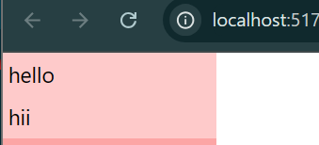

# 2.props with Object

import React from 'react'

**const** List2withDataObject = (props) **=>** {

  return (

    <div>

    <h1 className='bg-red-300 p-1 w-[10em]'><span>Animal:</span>{props.category!=="tiger"?props.name : "dog is innocent"} <span>Category:</span> {props.category}</h1>

  </div>

  )

}

export default List2withDataObject

sending objects

import React from 'react'

import './App.css'

import List from './components/List'

import List2withDataObject from './components/List2withDataObject'

**function** App() {

**const** data=[

    {

       name:"cat",

       category:"tiger"

    },

    {

       name:"dog",

       category:"wolf"

    }

  ]

  return (

    <>

   <List text="hello"/>

   <List text="hii"/>

   {data?.map((animal,index)**=>**{

   return  <List2withDataObject key={index} index={index} {...animal}/>

   })

   }

    </>

  )

}

export default App